

Practical No. : 1
Aim -
Demonstrate inline, internal, and external JavaScript; use console methods; create a webpage showing user info and a welcome message.
Software/Tools Required –
VSCode, Chrome, HTML%, CSS3, Javascript (ES6)
Experiment Program Code –
index.html
<html>
<head>
<title>
js lec1
</title>
<script>
function showWelcome() {
let name = document.getElementById("name").value;
let age = document.getElementById("age").value;

document.getElementById("output").innerHTML =
"<h2> Welcome, " + name + "!</h2>" + "<p> Your age is : " + age + "</p>";

console.log("User name : " + name);
console.info("User Age : " + age);
console.warm("This is a warning message");
console.error("This is a error message ");
}
</script>
</head>

<body>
<h1>User Info</h1>
<h4> Enter your name </h4>
<input type="text" id="name" placeholder="Enter name">
<h4>Enter your age </h4>
<input type="number" id="age" placeholder="Enter age">

<button onclick="showWelcome(); greet();"> Submit </button>

<hr>
<div id="output"> </div>
<script src="scriptt.js"> </script>
</body>
</html>

script.js
function greet() {
alert("Welcome to Javascript Programming");
console.table([
{
Name: "Sample User",
Course: "JavaScript"
}
]);
console.time("Execution");
console.timeEnd("Execution");
}
Output -
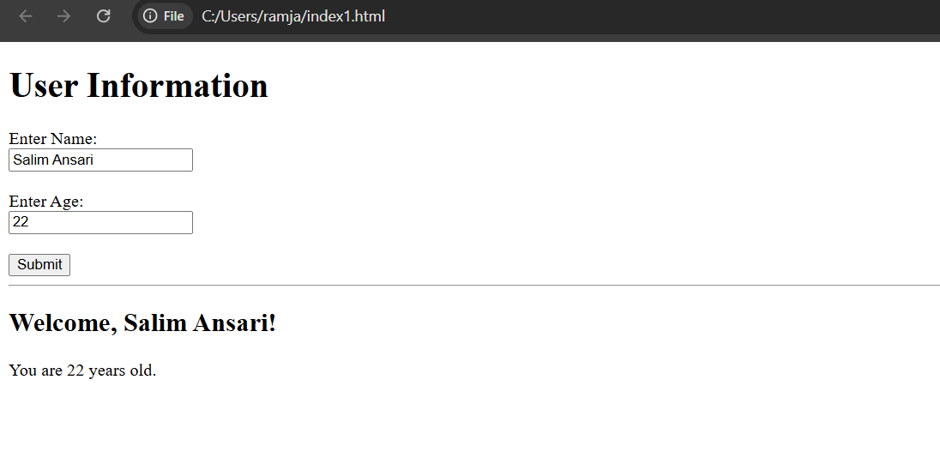
Case Study Title –
Create a webpage for college department and link the student information page with it and write a Java Script Program to Display "Welcome to SIT Nagpur! in an alert Box.

Case Study Program Code –

student.html

<!DOCTYPE html>
<html lang="en">
<head>
<meta charset="UTF-8" />
<meta name="viewport" content="width=device-width, initial-scale=1.0" />
<title>Student Information | Symbiosis Institute of Technology, Nagpur</title>
<link rel="stylesheet" href="style.css" />
</head>
<body onload="loadStudentInfo()">

<!-- Header -->
<header class="site-header">
<div class="header-inner">
<div class="logo-circle">SIT</div>
<div class="header-text">
<h1>Symbiosis Institute of Technology, Nagpur</h1>
<p>Department of Computer Science &amp; Engineering</p>
</div>
</div>
</header>

<!-- Navigation -->
<nav class="navbar">
<ul>
<li><a href="index.html">Home</a></li>
<li><a href="department.html">Department</a></li>
<li><a href="login.html">Student Login</a></li>
<li><a href="contact.html">Contact</a></li>
</ul>
</nav>

<!-- Page Title -->
<section class="page-title">
<h2>Student Information</h2>
<p>Your academic profile</p>
</section>

<!-- Main Content -->
<main class="container">
<section class="section">
<div class="student-card">
<div class="student-photo" id="stuPhotoInitial">S</div>
<div class="student-details">
<table>
<tbody>
<tr>
<th>Student Name</th>
<td id="stuName">-</td>
</tr>
<tr>
<th>Roll Number</th>
<td id="stuRoll">-</td>
</tr>
<tr>
<th>Student ID</th>
<td id="stuId">-</td>
</tr>
<tr>
<th>Gmail</th>
<td id="stuGmail">-</td>
</tr>
<tr>
<th>Department</th>
<td id="stuDept">-</td>
</tr>
<tr>
<th>Semester</th>
<td id="stuSemester">-</td>
</tr>
<tr>
<th>CGPA</th>
<td id="stuCgpa">-</td>
</tr>
<tr>
<th>Attendance</th>
<td id="stuAttendance">-</td>
</tr>
</tbody>
</table>
</div>
</div>

<div class="btn-row">
<a href="index.html" class="btn">Home</a>
<button class="btn btn-secondary" onclick="logout()">Logout</button>
</div>
</section>
</main>

<!-- Footer -->
<footer class="site-footer">
<p>&copy; 2026 Symbiosis Institute of Technology, Nagpur. All Rights Reserved.</p>
<p>Vidya Nagari, Wathoda Road, Nagpur, Maharashtra, India</p>
</footer>

<script src="script.js"></script>
</body>
</html>

index.html

<!DOCTYPE html>
<html>
<head>
<title>JavaScript Demo</title>
<!---Internal javascript-->
<script>
function showWelcome(){
let name = document.getElementById("name").value;
let age = document.getElementById("age").value;

document.getElementById("output").innerHTML =
"<h2>Welcome, " + name + "!</h2>" +
"<p>You are " + age + " years old.</p>";

console.log("User Name: " + name);
console.info("User Age: " + age);
console.warn("This is a warning message.");
console.error("This is an error message(demo purpose).")
}
</script>
</head>
<body>
<h1>User Information </h1>
<label> Enter Name: </label><br>
<input type="text" id="name" placeholder="Enter your name"><br><br>
<label> Enter Age: </label><br>
<input type="number" id="age" placeholder="Enter your age"><br><br>

<!---Inline JavaScript-->
<button onclick="showWelcome(); greet();">
Submit
</button>
<hr>
<div id="output"></div>
<!-- External JavaScript -->
<script src="script.js"></script>
</body>
</html>

Script.js

function greet(){
alert("Welcome to JavaScript programming!");
console.table([
{
Name: "Sample User",
Course:" JavaScript "
}
]);
console.time("Execution ");
console.timeEnd("Execution ");
}

Output –



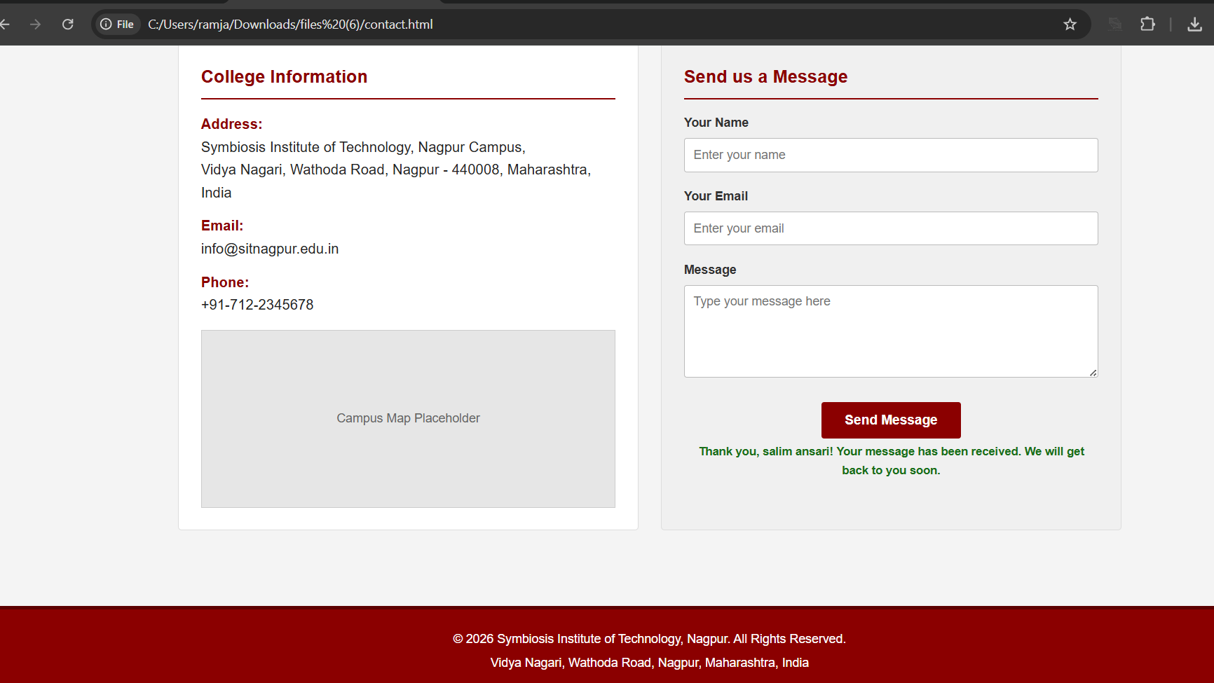

Conclusion –
Thus, the basic concepts of JavaScript were successfully studied and implemented. Different methods of including JavaScript, browser developer tools, console methods, alert boxes, DOM manipulation, and event handling were understood through the development of an interactive web page.

